**Optimizing Sales and Inventory Management for a Beverage Distributor: Insights and Efficiency Through BigQuery, Hive, and Spark**

**ADTA 5240**

**Harvesting, Storing, and Retrieving Data**

**Presented by**

Ashok Kumar Mettu, 11640819

Shanmukha Sai Ram Tummuri, 11703315

Kushal Kumar Reddy Kolli, 11639360

Laxmi Narsimha Reddy Racha, 11695049

Harshith Mamidishetty, 11634943

**Introduction:**

This documents provides step-by-step process and technical plow for Sales and inventory Management projects. This includes the screenshots and explanation for each of the step. Steps start from uploading and storing the dataset to visualization to ensure reproducibility and clarity.

The main aim of this project is to improve the decision making in inventory allocation, sale forecasting, and supplier management.

**Data Lifecycle:**

1. **Data Collection:** This dataset consists of historical sales data from a beverage distributor downloaded from data.gov website.
2. **Data Storage**: To store this dataset we used a cloud data warehouse called BigQuery provided by Google Cloud Platform.

GCP Setup and upload:

1. Login GCP
2. Create a storage bucket to store the dataset
3. Upload the dataset to that bucket.
4. Set up a BigQuery Table and upload the dataset.

The dataset is successfully uploaded to the GCP bucket. This is a centralized storage for subsequent processing. The screenshots shows out dataset “Updated_Sales” uploaded successfully into the bucket with correct schema.

1. **Data Processing**: The data is processed by handling null values, renaming columns, and cleaning the data.

Now we will do some data exploration. To understand the structure of the dataset. Try to identify if any missing data or outliers in the dataset as this might affect the analysis.

Check if everything is imported correctly.

Looks like there are some null values present in particular problem which will be handled in later steps.

1. **Data Analysis**: performed analysis using SQL in BigQuery to generate total sales by supplier, retail sales trends, and sales ratios.

Lets first run some simple queries in BigQuery.

**Query 1.** Check table content

SELECT * FROM `Sales_Beverages.Updated_Sales` LIMIT 10;

This query verified that the dataset was imported correctly into BigQuery.

**Query 2.** Print distinct SUPPLIER from the table

This query displays all the different suppliers who supply beverages to this company.

Now, Lets check for null values:

SELECT

  COUNTIF(YEAR IS NULL) AS null_years,

  COUNTIF(MONTH IS NULL) AS null_months,

  COUNTIF(SUPPLIER IS NULL) AS null_suppliers,

  COUNTIF(ITEM_CODE IS NULL) AS null_item_codes,

  COUNTIF(ITEM_DESCRIPTION IS NULL) AS null_item_descriptions,

  COUNTIF(ITEM_TYPE IS NULL) AS null_item_types,

  COUNTIF(RETAIL_SALES IS NULL) AS null_retail_sales,

  COUNTIF(RETAIL_TRANSFERS IS NULL) AS null_retail_transfers,

  COUNTIF(WAREHOUSE_SALES IS NULL) AS null_warehouse_sales

FROM `Sales_Beverages.Updated_Sales`

This query identified that there are some columns with missing values which we will address in subsequent steps.

**Remove NULL values.**

To remove NULL values we substituted null values to the corresponding values as below

1. All NULL values in SUPPLIER columns are replaced by “Unknown”

Update SUPPLIER column where it's NULL

UPDATE `Sales_Beverages.Updated_Sales`

SET SUPPLIER = 'Unknown'

WHERE SUPPLIER IS NULL;

1. All NULL values in ITEM_TYPE columns are replaced by “Unknown”

Update ITEM_TYPE column where it's NULL

UPDATE `Sales_Beverages.Updated_Sales`

SET ITEM_TYPE = 'Unknown'

WHERE ITEM_TYPE IS NULL;

1. All NULL values in RETAIL_SALES columns are replaced by “0”

Update RETAIL_SALES column where it's NULL

UPDATE `Sales_Beverages.Updated_Sales`

SET RETAIL_SALES = 0

WHERE RETAIL_SALES IS NULL;

`

Verifying the above activity.

Successfully all null values are removed.

1. **EDA:**

Lets now understand the distribution and structure of data.

Find mean, median, standard deviation and count for numeric fields **RETAIL_SALES**, **RETAIL_TRANSFERS**, **WAREHOUSE_**SALES to find the central tendency and variability of the data.

SELECT

  AVG(RETAIL_SALES) AS avg_sales,

  APPROX_QUANTILES(RETAIL_SALES, 2)[OFFSET(1)] AS median_retail_sales,  -- 50th percentile is the median

  STDDEV(RETAIL_SALES) AS stddev_sales,

  COUNT(*) AS total_records

FROM `Sales_Beverages.Updated_Sales`

SELECT

  AVG(RETAIL_SALES) AS avg_sales,

  STDDEV(RETAIL_SALES) AS stddev_sales,

  COUNT(*) AS total_records

FROM `Sales_Beverages.Updated_Sales`;

**Get total sales by grouping Supplier and Item Type:**

SELECT

  SUPPLIER,

  ITEM_TYPE,

  SUM(RETAIL_SALES) AS total_retail_sales,

  SUM(RETAIL_TRANSFERS) AS total_retail_transfers,

  SUM(WAREHOUSE_SALES) AS total_warehouse_sales

FROM `Sales_Beverages.Updated_Sales`

GROUP BY SUPPLIER, ITEM_TYPE

ORDER BY total_retail_sales DESC

**Creating performance metrics:**

1. Sales Ratio:
2. Understand how the sales relate to what is in the warehouse, calculate ratio between RETAIL_SALES and WAREHOUSE_SALES
3. calculate the ratio of RETAIL SALES to RETAIL TRANSFERS to analyze if there's a high sales-to-transfer rate.

SELECT

SUPPLIER,

ITEM_TYPE,

SUM(RETAIL_SALES) / NULLIF(SUM(WAREHOUSE_SALES), 0) AS sales_to_warehouse_ratio,

SUM(RETAIL_SALES) / NULLIF(SUM(RETAIL_TRANSFERS), 0) AS sales_to_transfer_ratio

FROM `Sales_Beverages.Updated_Sales`

GROUP BY SUPPLIER, ITEM_TYPE

**Find Monthly trends**

Analyze how the sales, transfers, and warehouse sales change over time (by **MONTH** and **YEAR**).

SELECT

  YEAR,

  MONTH,

  SUM(RETAIL_SALES) AS monthly_retail_sales,

  SUM(RETAIL_TRANSFERS) AS monthly_retail_transfers,

  SUM(WAREHOUSE_SALES) AS monthly_warehouse_sales

FROM `Sales_Beverages.Updated_Sales`

GROUP BY YEAR, MONTH

ORDER BY YEAR, MONTH

1. **Data Presentation**:

Created visualizations in Tableau, including total retail sales by supplier, sales trends over time, and sales ratios.

Now export the data to TABLEAU.

1. Visualize total retail sales by supplier.

We can see the supplier and total retail sales of each of them.

Extract data for Sales Trends Over Time

SELECT

  YEAR,

  MONTH,

  SUM(RETAIL_SALES) AS total_retail_sales

FROM

  `Sales_Beverages.Updated_Sales`

GROUP BY

  YEAR, MONTH

ORDER BY

  YEAR ASC, MONTH ASC;

Similarly for sales ratio

SELECT

  ITEM_TYPE,

  RETAIL_SALES,

  WAREHOUSE_SALES,

  IF(WAREHOUSE_SALES = 0, NULL, RETAIL_SALES / WAREHOUSE_SALES) AS sales_ratio

FROM

   `Sales_Beverages.Updated_Sales`

WHERE

  WAREHOUSE_SALES IS NOT NULL AND RETAIL_SALES IS NOT NULL

ORDER BY

  ITEM_TYPE;

STEP 2: Hadoop Clusters

Hive and Spark

Step 1 create tables in Hive and Spark simultaneously.

1. Creating table in Hive

Step 1: Search for clusters in GCP and start the cluster.  
  
Now navigate to compute engine>>VM Instances

Open SSH of the manager node.

Step 1 will be Moving data to HDFS: to do it we do below steps.

Check existing directories available.

hdfs dfs -ls /

hdfs dfs -ls /user

Now we will create a personal directory.

hdfs dfs -mkdir /user/lnarasimha

hdfs dfs -mkdir /user/lnarasimha/data

hdfs dfs -mkdir /user/lnarasimha/data/sales

First move the files from GCP cloud storage to manager node.

mkdir DATA

cd DATA

Copy the dataset from the GCP bucket to the manager node.

gsutil cp gs://**f22assign5lnr**/data/ [Warehouse_and_Retail_Sales.csv](https://console.cloud.google.com/storage/browser/_details/f22assign5lnr/data/Warehouse_and_Retail_Sales.csv?pageState=(%22StorageObjectListTable%22:(%22f%22:%22%255B%255D%22))&inv=1&invt=AbiGKA&project=adta5240a5lnr) [Warehouse_and_Retail_Sales.csv](https://console.cloud.google.com/storage/browser/_details/f22assign5lnr/data/Warehouse_and_Retail_Sales.csv?pageState=(%22StorageObjectListTable%22:(%22f%22:%22%255B%255D%22))&inv=1&invt=AbiGKA&project=adta5240a5lnr)

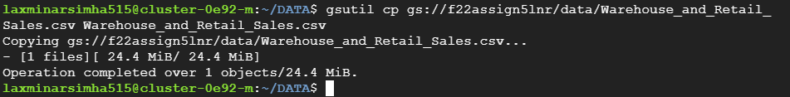

Load Data into HDFS:

hdfs dfs -put [Warehouse_and_Retail_Sales.csv](https://console.cloud.google.com/storage/browser/_details/f22assign5lnr/data/Warehouse_and_Retail_Sales.csv?pageState=(%22StorageObjectListTable%22:(%22f%22:%22%255B%255D%22))&inv=1&invt=AbiGKA&project=adta5240a5lnr) /user/lnarasimha/data/sales

hdfs dfs -ls /user/lnarasimha/data/sales

SETUP:HIVE

Access hive using beeline -u jdbc:hive2://localhost:10000

CREATE EXTERNAL TABLE IF NOT EXISTS sales_data (

year INT,

month INT,

supplier STRING,

item_code INT,

item_desc STRING,

item_type STRING,

retail_sales FLOAT,

retail_transfers FLOAT,

warehouse_sales FLOAT

)

ROW FORMAT DELIMITED

FIELDS TERMINATED BY ','

STORED AS TEXTFILE

LOCATION '/user/lnarasimha/data/sales/';

Run a sample query.

SELECT * FROM sales_data LIMIT 5;

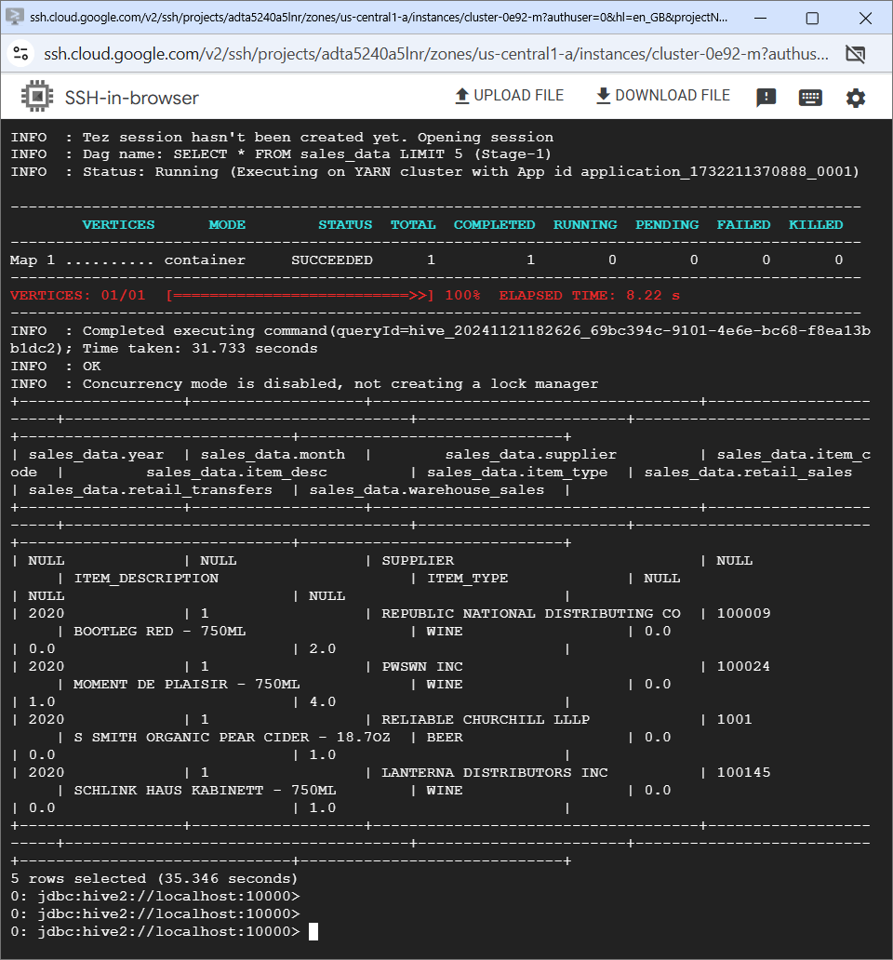

Now Open New SSH from manager node.

Open spark-sql

>>spark-sql

Create table in spark.

CREATE TABLE spark_sales_data(

year INT,

month INT,

supplier STRING,

item_code INT,

item_desc STRING,

item_type STRING,

retail_sales FLOAT,

retail_transfers FLOAT,

warehouse_sales FLOAT

)

USING CSV

OPTIONS (

path '/user/lnarasimha/data/sales/Warehouse_and_Retail_Sales.csv',

header 'true',

inferSchema 'true'

);

Now Lets run Queries to compare the response times in hive and spark.

**Query 1: Total Warehouse Sales by Supplier**

**Hive:**

SELECT supplier, SUM(warehouse_sales) AS total_warehouse_sales

FROM sales_data

GROUP BY supplier

ORDER BY total_warehouse_sales DESC

LIMIT 5;

**Spark:**

SELECT supplier, SUM(warehouse_sales) AS total_warehouse_sales

FROM spark_sales_data

GROUP BY supplier

ORDER BY total_warehouse_sales DESC;

Output:

|  |  |  |  |
| --- | --- | --- | --- |
| Query | Hive Execution Time | Spark Execution Time | Performance Improvement |
| Query 1 | 15.57 (S) | 11.561(S) | 25.75% |

**Query 2: Total Sales Metrics by Year**

**Hive:**

SELECT year,

SUM(retail_sales) AS total_retail_sales,

SUM(retail_transfers) AS total_retail_transfers,

SUM(warehouse_sales) AS total_warehouse_sales

FROM sales_data

GROUP BY year;

**Spark:**

SELECT year,

SUM(retail_sales) AS total_retail_sales,

SUM(retail_transfers) AS total_retail_transfers,

SUM(warehouse_sales) AS total_warehouse_sales

FROM spark_sales_data

GROUP BY year;

The table below compares Hive and Spark SQL execution times, showing Spark’s superior performance.

|  |  |  |  |
| --- | --- | --- | --- |
| Query | Hive Execution Time | Spark Execution Time | Performance Improvement |
| Query 2 | 9.117 (S) | 2.567(S) | 71.84% |

**Query 3: Top 5 Items with Highest Retail Sales**

**Hive:**

SELECT item_desc,

SUM(retail_sales) AS total_sales

FROM sales_data

GROUP BY item_desc

ORDER BY total_sales DESC

LIMIT 5;

**SPARK**

SELECT item_desc,

SUM(retail_sales) AS total_sales

FROM spark_sales_data

GROUP BY item_desc

ORDER BY total_sales DESC

LIMIT 5;

The table below compares Hive and Spark SQL execution times, showing Spark’s superior performance.

|  |  |  |  |
| --- | --- | --- | --- |
| Query | Hive Execution Time | Spark Execution Time | Performance Improvement |
| Query 3 | 12.934 (S) | 2.507(S) | 80.62% |

**Query 4: Top 5 Suppliers by Warehouse Sales**

**Hive:**

SELECT supplier,

SUM(warehouse_sales) AS total_warehouse_sales

FROM sales_data

GROUP BY supplier

ORDER BY total_warehouse_sales DESC LIMIT 5;

**Spark:**

SELECT supplier,

SUM(warehouse_sales) AS total_warehouse_sales

FROM spark_sales_data

GROUP BY supplier

ORDER BY total_warehouse_sales DESC

LIMIT 5;

The table below compares Hive and Spark SQL execution times, showing Spark’s superior performance.

|  |  |  |  |
| --- | --- | --- | --- |
| Query | Hive Execution Time | Spark Execution Time | Performance Improvement |
| Query 4 | 10.38 (S) | 1.323 (S) | 87.25% |

**Sample queries for analysis:**

**Query 5: Comparison of Liquor, Beer, and Wine Sales:**

**Hive:**

SELECT item_type,

SUM(retail_sales) AS total_retail_sales,

SUM(warehouse_sales) AS total_warehouse_sales

FROM sales_data

WHERE item_type IN ('LIQUOR', 'BEER', 'WINE')

GROUP BY item_type;

**Query 5: Retail and Warehouse Sales by Item Type**

**Spark:**

SELECT item_type,

SUM(retail_sales) AS total_retail_sales,

SUM(warehouse_sales) AS total_warehouse_sales

FROM spark_sales_data

WHERE item_type IN ('LIQUOR', 'BEER', 'WINE')

GROUP BY item_type;

